EXPERIMENT-4
NAME: Yuvaraj A ROLL NO:240701809
Create a prototype with familiar and unfamiliar navigation elements. Evaluate ease of use with different user groups using proto.io
Screen 1:

Sign In page for the destination app
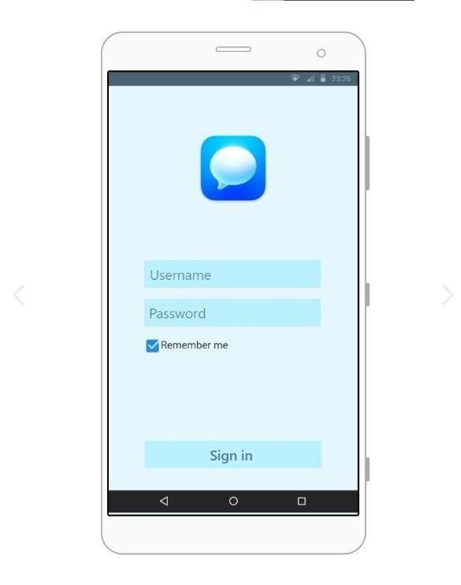
Familiar Icons:
1. Sign In Button:
A clearly labeled action button.
Standard primary action element.
Possibly Unfamiliar or Missing Icons:
- Missing Back Button:
Users may not know how to navigate to the previous page.
- Missing Sign Up Option:
New users may not know how to create an account.
- Missing Forgot Password Link:
Users who forget their password may not find recovery options.
- Missing Page Title (Login):
Lack of a clear heading may confuse users about the current screen.
Screen 2:
Home page:
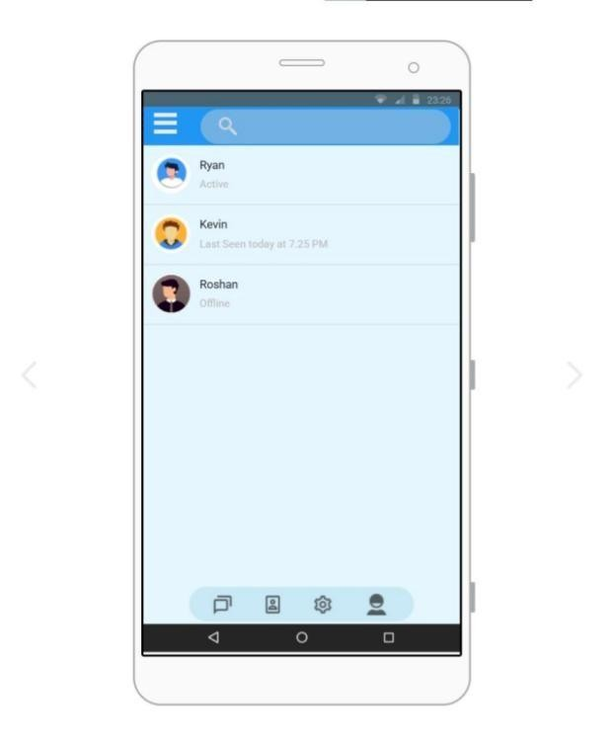 Familiar Icons:
- Hamburger Menu – Top Left:
Common icon used to open a navigation drawer or sidebar.
- Search Icon – Top Bar:
Widely recognized symbol for searching contacts or conversations.
- Profile Avatars – Next to Names:
Circular user images commonly used in chat applications.
- Status Text (Active / Last Seen / Offline):
Standard way to show user availability in messaging apps.
- Bottom Navigation Icons:
Common layout for switching between main sections like chats, contacts, settings, and profile.

Screen3:

Home Page with Navigation Drawer
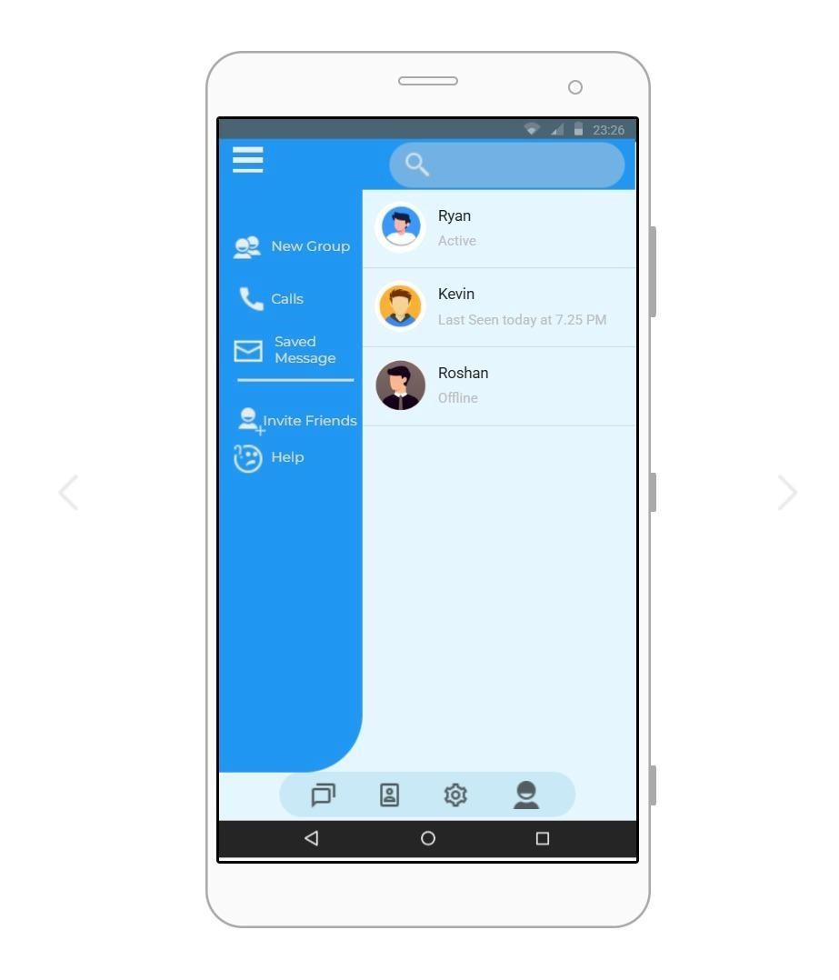 Familiar Icons:
- Hamburger Menu – Top Left:
Standard icon used to open the side navigation drawer.
- Search Icon – Top Bar:
Commonly used to search chats or contacts.
- Navigation Drawer (Sidebar Menu):
Widely used mobile pattern for accessing additional options.
- Call Icon – Next to “Calls”:
Recognizable symbol for call-related features.
- Envelope Icon – Next to “Saved Message”: Common symbol for messages.
- Help Icon – Next to “Help”:
Standard representation for support or assistance.

Screen4:

Chat Screen – Familiar UI Elements
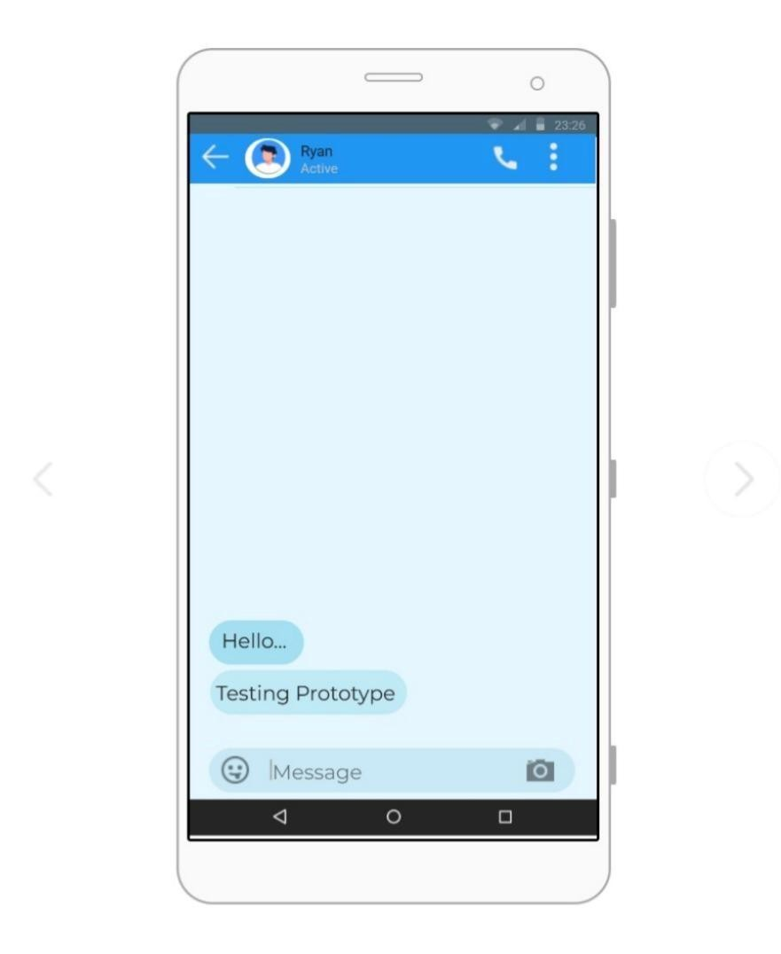
- Back Arrow (Top Left)
  - Commonly used across messaging apps for returning to the previous screen.
  - Helps users quickly navigate back without confusion.
- Call Icon (Top Right)
  - Standard icon indicating the ability to make a voice call.
  - Instantly recognizable due to its frequent use in communication apps.
- Three-Dot Menu
  - A familiar symbol for additional actions or settings.
  - Users expect this to open a small menu for chat-specific options.
- Message Input Field (Bottom)
  - Standard text area used for typing and sending messages.
  - Consistently placed at the bottom in almost all chat applications.
- Emoji and Camera Icons
  - Commonly found within chat input bars for quick emoji access and media sharing.
  - Their placement makes interaction intuitive and predictable.

Screen 5:

Profile Screen – Familiar UI Elements
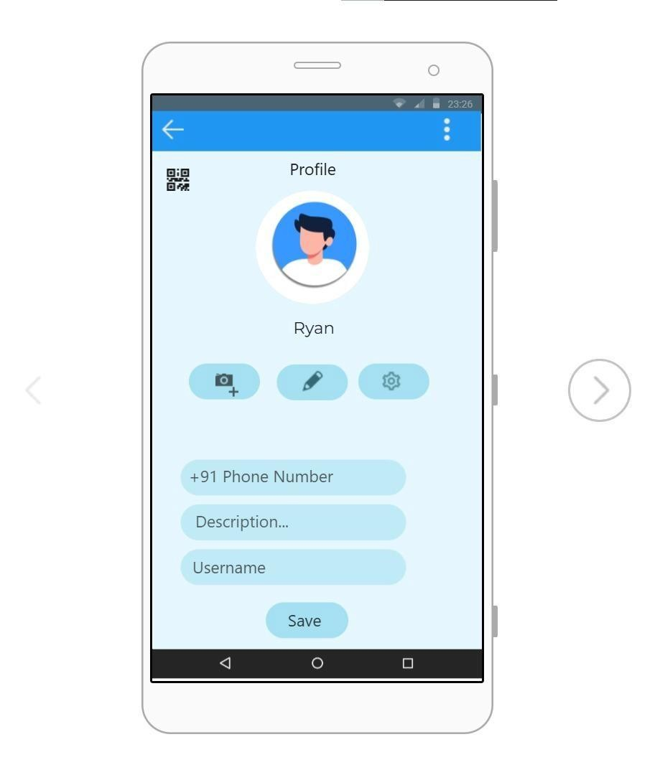

- Back Arrow (Top Left)
  - A widely recognized navigation tool to return to the previous page.
  - Maintains consistency across app screens.
- Profile Picture (Center)
  - Circular avatar is a standard representation of user identity.
  - Positioned centrally to highlight user information.
- Camera Icon for Photo Update
  - A known symbol for changing or uploading profile photos.
  - Users easily understand its purpose without explanation.
- Edit (Pencil) Icon
  - Universally used to indicate editing of information.
  - Makes profile customization simple and clear.
- Settings (Gear) Icon
  - Common icon for managing account or profile settings.
  - Helps users locate configuration options quickly.

Prototype Link: https://pr.to/O32UMO/

